Project Title: AI-Powered Nutrition Analyzer For Fitness Enthusiasts Project Design Phase-I - Problem Solution Fit

Team ID: PNT2022TMID10584

Fitness Enthusiasts who like to lead a healthy life and well balanced diet

* Lack of inaccurate information about food nutrition values.
* Only thinking about leading a healthy life without taking actions.
* Not having a personal assistant to monitor their daily nutritional intake

They can hire a personal Nutritionist. They can consult dietitians. They can use apps. There are many apps like My Fitness Pal, Chromometer, Life sum, etc…. which people resort to for good health.

Individual physical exercise or yoga without prior knowledge may lead to muscle cramp. So can be tackled by use of animated guide videos for that.

Duetofastpacedlifestyle, Availability oflowquality and

nutrition less food, Improper diet plan, Lack of health related awareness, Emotional eating, not following strict timings

* Have a regular and enough sleep
* Have an application to track their daily nutrition values.
* Have a perfectly balanced diet plan

To maintain good health and to regulate their eating and good intake of foods.

ONLINE: Taking advice from the nutrition expert and following ﬁtness based online apps.

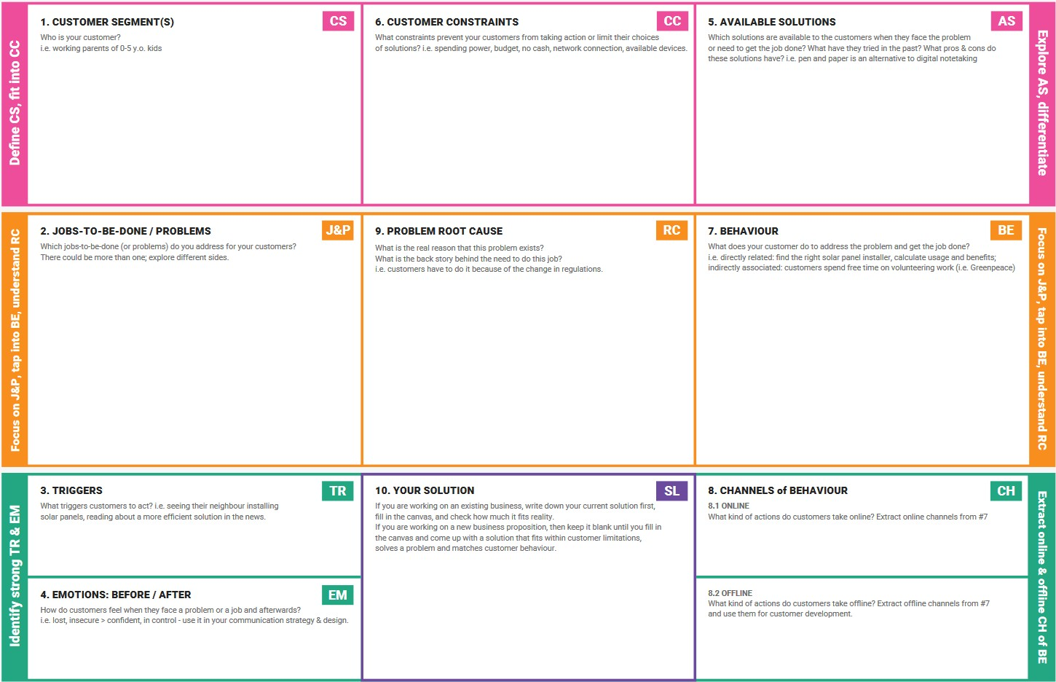

Creating a web application for users to track, monitor and maintain their health by performing specialized suggestions for each and every user.

OFFLINE: Working out regularly, and maintaining the regular activities as per the prescribed schedule

**4. EMOTIONS: BEFORE / AFTER**

Before: People can’t track their health details. People can’t improve their health in proper Manner

After:Users can maintain and can improve theirBody ﬁtness